SECTION B.

QUESTION 4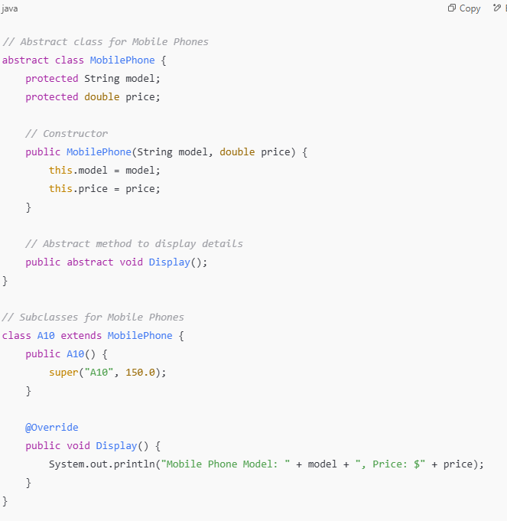

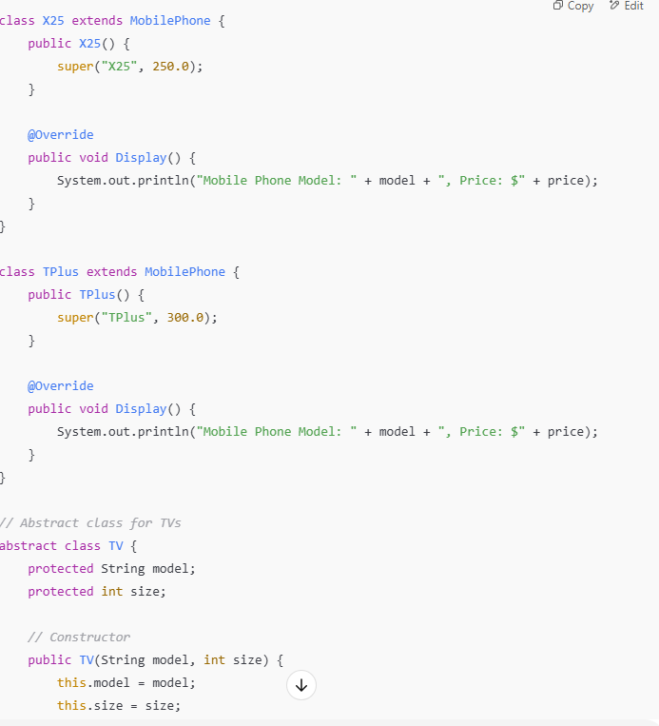

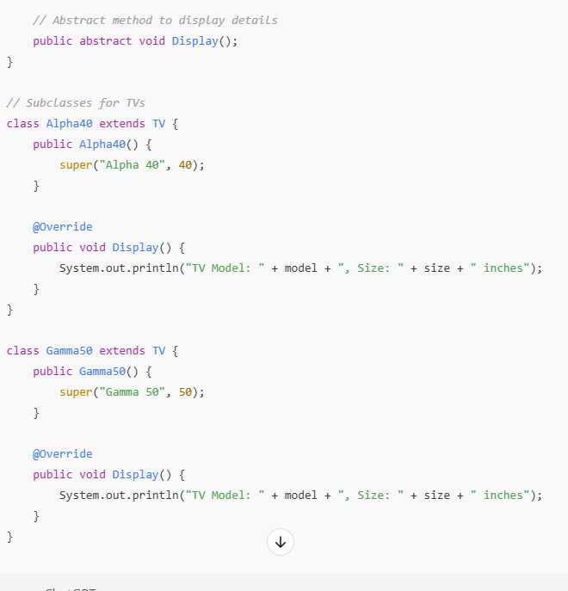

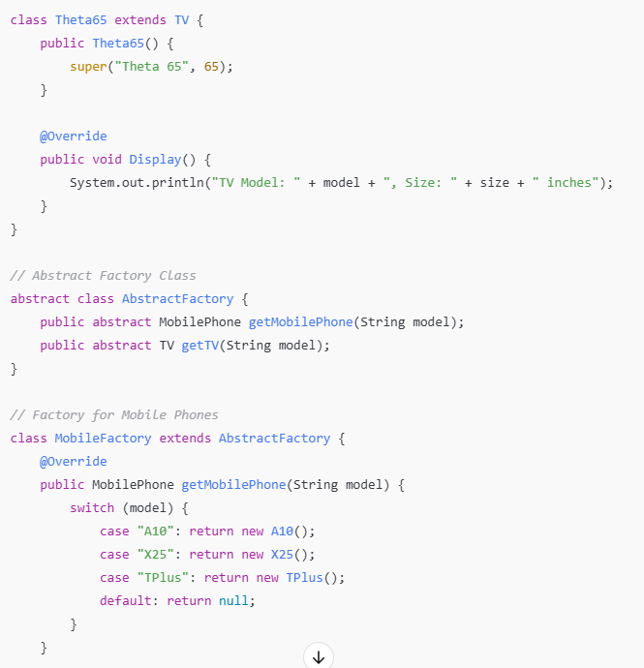

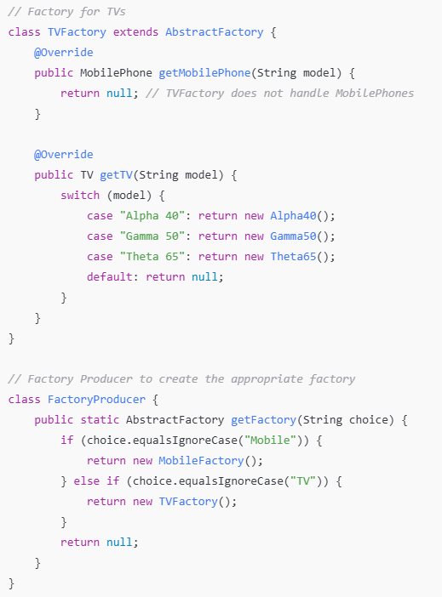

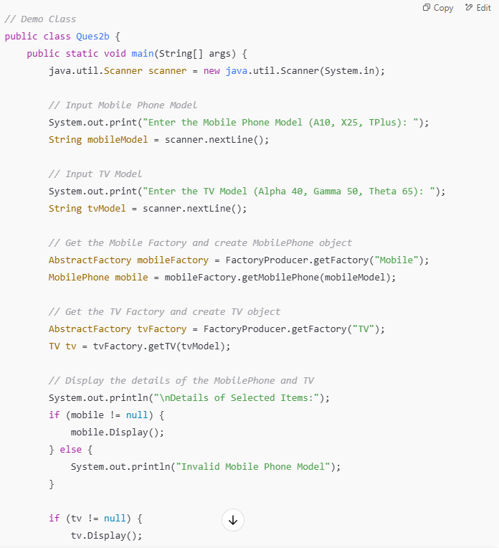

**Explanation of the Code:**

1. **Abstract Classes**:
   * MobilePhone and TV are abstract classes that define the common properties and behaviors of mobile phones and TVs, respectively.
   * Both have an abstract Display() method to display their details.
2. **Subclasses**:
   * Subclasses (A10, X25, TPlus, Alpha40, Gamma50, Theta65) extend the abstract classes and implement the Display() method.
3. **Factories**:
   * MobileFactory creates mobile phone objects.
   * TVFactory creates TV objects.
4. **AbstractFactory**:
   * An abstract class that defines the method signatures for creating objects.
   * Concrete factories (MobileFactory, TVFactory) implement these methods.
5. **FactoryProducer**:
   * Produces the appropriate factory (MobileFactory or TVFactory) based on the input.
6. **Main Class** (Ques2b):
   * Prompts the user for mobile and TV models.
   * Uses the factories to create objects and display their details.

**Sample Input/Output:**

**Input:**

mathematica

CopyEdit

Enter the Mobile Phone Model (A10, X25, TPlus): A10

Enter the TV Model (Alpha 40, Gamma 50, Theta 65): Gamma 50

**Output:**

yaml

CopyEdit

Details of Selected Items:

Mobile Phone Model: A10, Price: $150.0

TV Model: Gamma 50, Size: 50 inches